Superposition

5-5 Main Question (สำหรับแสดงข้อสอบ)

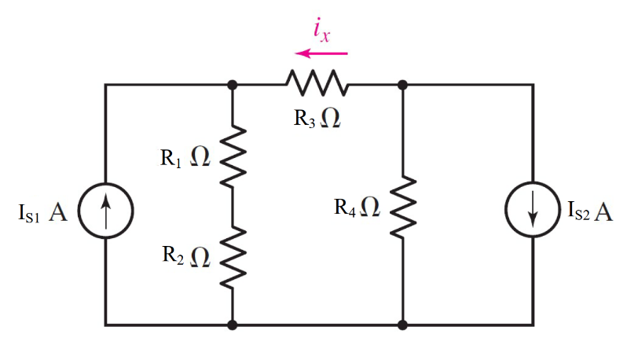

Given *I*s1 = 3 A, *I*s2 = 5 A, *R*1 = 12 Ω, *R*2 = 2 Ω, *R*3 = 5 Ω, *R*4 = 5 Ω.

Find

current *Ix* due to voltage source *I*1 = {#1}

current *I*x due to voltage source *I*2 = {#2}

current *Ix* = {#3}

Variables (สำหรับเขียนโค้ดเพื่อหาคำตอบ)

Random variables

I1 = {1:5}; I2 = {5:10};

R1 = {10:15}; R2 = {1:5}; R3 = {1:5}; R4 = {1:5};

Global variables

#I1 = 3; I2 = 5; R1 = 12; R2 = 2; R3 = 5; R4 = 5;

RT=R1+R2+R3+R4;

IxI1 =-I1\*((R1+R2)/RT);

IxI2 = -I2\*(R4/RT);

Ix = IxI1+IxI2;

Part (กรอกคำตอบ)

1. IxI1 = -2.7917 A

2. IxI2 = -1.0417 A

3. Ix = -2.791 A

5-8 Main Question (สำหรับแสดงข้อสอบ)

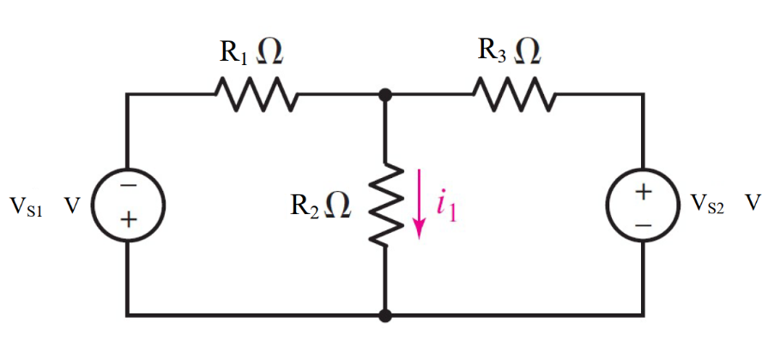

Given *V*s1 = 4 V, *V*s2 = 10 V, *R*1 = 3 Ω, *R*2 = 6 Ω, *R*3 = 4 Ω.

Find

current *I1* due to voltage source *E*1 = {#1}

current *I1* due to voltage source *E*2 = {#2}

current *I1* = {#3}

Variables (สำหรับเขียนโค้ดเพื่อหาคำตอบ)

Random variables

E1 = {5:10}; E2 = {5:10};

R1 = {1:5}; R2 = {5:10}; R3 = {1:5};

Global variables

#E1 = 4; E2 = 10; R1 = 3; R2 = 6; R3 = 4;

IE1 =-E1/(R1+R2\*R3/(R2+R3));

I1E1 = R3/(R2+R3)\*IE1;

IE2 = E2/(R3+R1\*R2/(R1+R2));

I1E2 = R1/(R1+R2)\*IE2;

I1 = I1E1+I1E2;

Part (กรอกคำตอบ)

1. I1E1 = -0.2963 A

2. I1E2 = 0.5557 A

3. I1 = 0.2593 A

5-10 Main Question (สำหรับแสดงข้อสอบ)

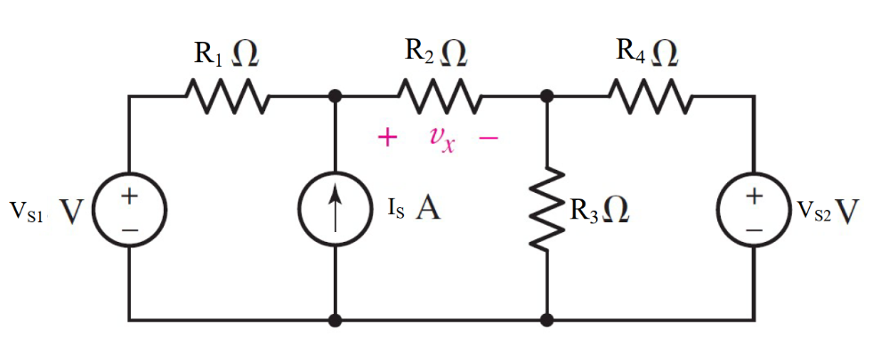

Given *V*s1 = 4 V, *V*s2 = 4 V, *I*s = 2 A, *R*1 = 3 Ω, *R*2 = 1 Ω, *R*3 = 5 Ω, *R*4 = 2 Ω.

Find

current *Vx* due to voltage source *E*1 = {#1}

current *Vx* due to voltage source *E*2 = {#2}

current *Vx* due to voltage source *I*s = {#3}

current *V*x= {#3}

Variables (สำหรับเขียนโค้ดเพื่อหาคำตอบ)

Random variables

I1 = {1:5}; I2 = {5:10};

R1 = {10:15}; R2 = {1:5}; R3 = {1:5}; R4 = {1:5};

Global variables

#E1 = 4; E2 = 4; Is = 2; R1 = 3; R2 = 1; R3 = 5; R4 = 2;

R34=(R3\*R4)/(R3+R4);

R32=(R3\*(R1+R2))/ (R3+R1+R2);

VxE1 =E1\*(R2/(R1+R2+R34));

V5 = E2\*(R32/(R32+R4));

VxE2 = -1\*V5\*(R2/(R1+R2));

Ir2= Is\*(R1/(R1+R2+R34));

VxI1= Ir2\*R2;

Vx = VxI1+VxE1+VxE2;

Part (กรอกคำตอบ)

1. VxE1 = 0.7368 V
2. VxE2 = -0.5263 V
3. VxI1 = 1.1053 V
4. Vx = 1.3158 V

5-11 Main Question (สำหรับแสดงข้อสอบ)

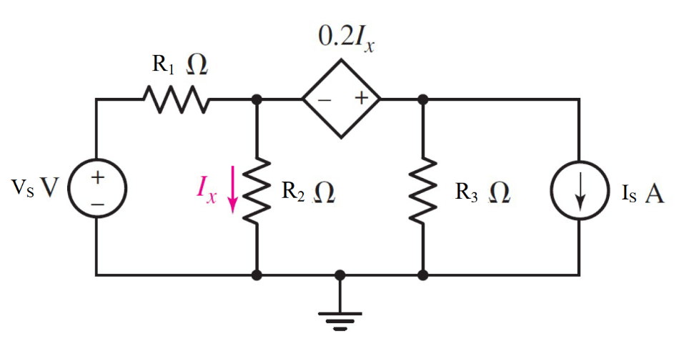

Given *V*s = 1 V, *I*s = 2 A, *R*1 = 5000 Ω, *R*2 = 7000 Ω, *R*3 = 2000 Ω,

Find

current *I* due to voltage source *E*S = {#1}

current *I* due to voltage source *Is* = {#2}

current *I* = {#3}

Variables (สำหรับเขียนโค้ดเพื่อหาคำตอบ)

Random variables

VS = {1:5}; IS = {1:5};

R1 = {1000:5000:1000}; R2 = {1000:10000:1000}; R3 = {1000:5000:1000};

Global variables

#Es = 1; Is = 2; R1 = 5000; R2 = 7000; R3 = 2000;

G11 = 1/R1+1/R2; G12 = 1/R3; G21 = -1-0.2/R2; G22 = 1;

I1IS = -Is; I1ES = Es/R1; I2 = 0;

D = G11\*G22-G12\*G21;

D1IS = I1IS\*G22-I2\*G12;

D1ES = I1ES\*G22-I2\*G12;

D2IS = G11\*I2-G21\*I1IS;

D2ES = G11\*I2-G21\*I1ES;

V1IS = D1IS/D; V2IS = D2IS/D; V1ES = D1ES/D; V2ES = D2ES/D;

IxIS = V1IS/R2;

IxES = V1ES/R2;

Ix = IxIS + IxES;

Part (กรอกคำตอบ)

1. IxES = 3.3898e-5 A
2. IxIS = -0.3390 A
3. Ix = -0.3389 A

5-12 Main Question (สำหรับแสดงข้อสอบ)

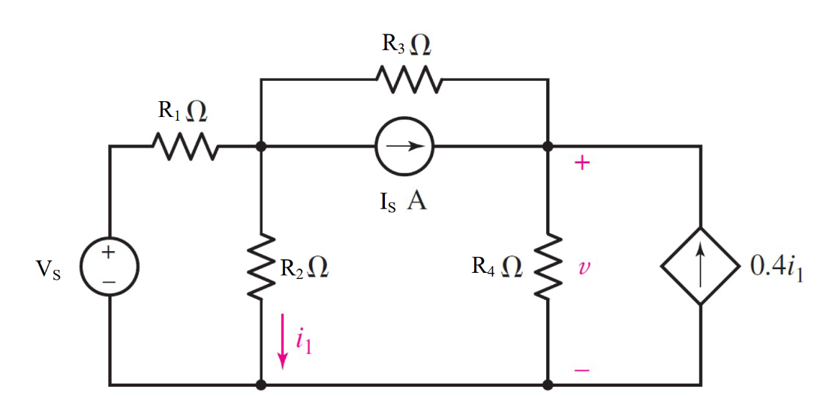

Given *V*s = 1 V, *I*s = 2 A, *R*1 = 7 Ω, *R*2 = 2 Ω, *R*3 = 1 Ω, *R*4 = 3 Ω,

Find

current *I1* due to voltage source *E*S = {#1}

current *I1* due to voltage source *Is* = {#2}

current *I1* = {#3}

Variables (สำหรับเขียนโค้ดเพื่อหาคำตอบ)

Random variables

I1 = {1:5}; I2 = {5:10};

R1 = {10:15}; R2 = {1:5}; R3 = {1:5}; R4 = {1:5};

Global variables

#Es = 4; Is = 6; R1 = 7; R2 = 2; R3 = 1;R4=3;

G11 = 1/R1+1/R2+1/R3; G12 = -1/R3; G21 = -1-0.4/R2; G22 = 1/R3+1/R4;

I1IS = -Is; I1ES = Es/R1; I2IS = Is; I2ES=0;

D = G11\*G22-G12\*G21;

D1IS = I1IS\*G22-I2IS\*G12;

D1ES = I1ES\*G22-I2ES\*G12;

D2IS = G11\*I2IS-G21\*I1IS;

D2ES = G11\*I2ES-G21\*I1ES;

V1IS = D1IS/D; V2IS = D2IS/D; V1ES = D1ES/D; V2ES = D2ES/D;

IxIS = V1IS/R2;

IxES = V1ES/R2;

Ix = IxIS + IxES;

Part (กรอกคำตอบ)

1. I1ES = 0.3846 A
2. I1IS = -1.0096 A
3. I1 = -0.625 A